The goal of lab 1 was to begin the operation of testing the PCB to prove it as being functional. Measurements of the output of the 5-volt Regulator show were taken to prove that the power conditioning circuit was built and implemented properly, as well as shown to conditioning much higher voltages than should be needed (Figures 2-6). An LED was blinked through the use of PB0 on the microcontroller to prove that the ISP interface and microcontroller were both fully functional.

Issues were faced that impeded the completion of the lab. The first iteration of testing the power circuit showed that no power was reaching the board from the input. It was concluded that the issue stemmed from the regulator portion of the circuit. It was presumed that the regulator itself was the problem, but it is also possible that an internal connection was severed or had never existed in the first place. To remedy this, a second regulator was acquired and subsequently installed. During this process, the small pads the regulator is meant to be installed in were damaged. This led the regulator to being attached off the board and connected via soldered wires to capacitors attached to its input and output. Power was restored and successfully regulated after this. The Atmel Studio software was not allowing the code to be uploaded without restarting the software every single use. This is believed to be an issue with the software and did not impede completion of the exercise once the overall issues had been remedied, allowing for the blinking of the LED and proof that the ISP interfacing was successful.

To summarize, despite issues with the board, ISP IDE and general software, the 5-volt regulator successfully works, conditioning the input power and providing steady DC voltage sufficient for the microcontroller to operate. The ISP interfacing was also successfully demonstrated and allowed software to be installed on the controller to blink an LED.

Appendix

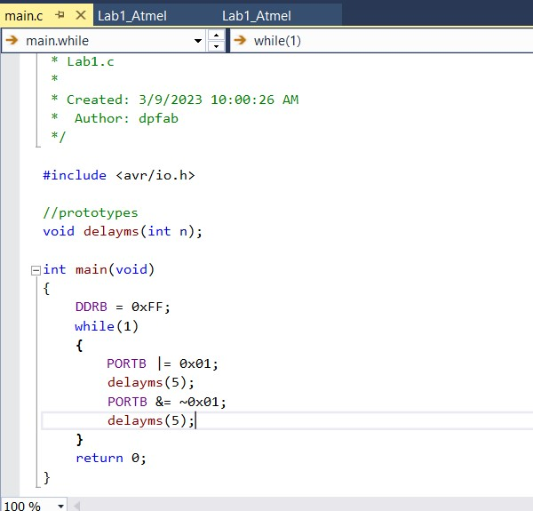

Figure : Code used to blink LED

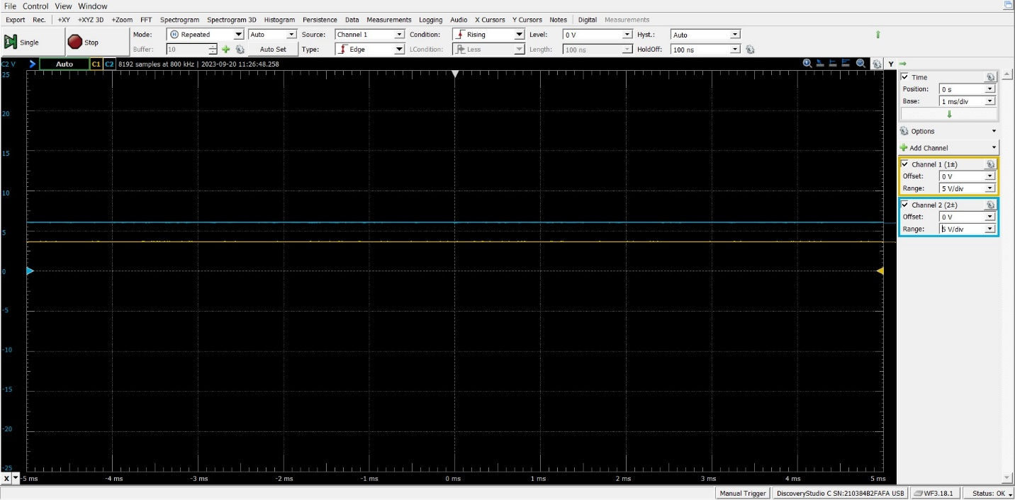

Figure : Input (blue) to voltage regulator of 6V and output (yellow) of under 5V

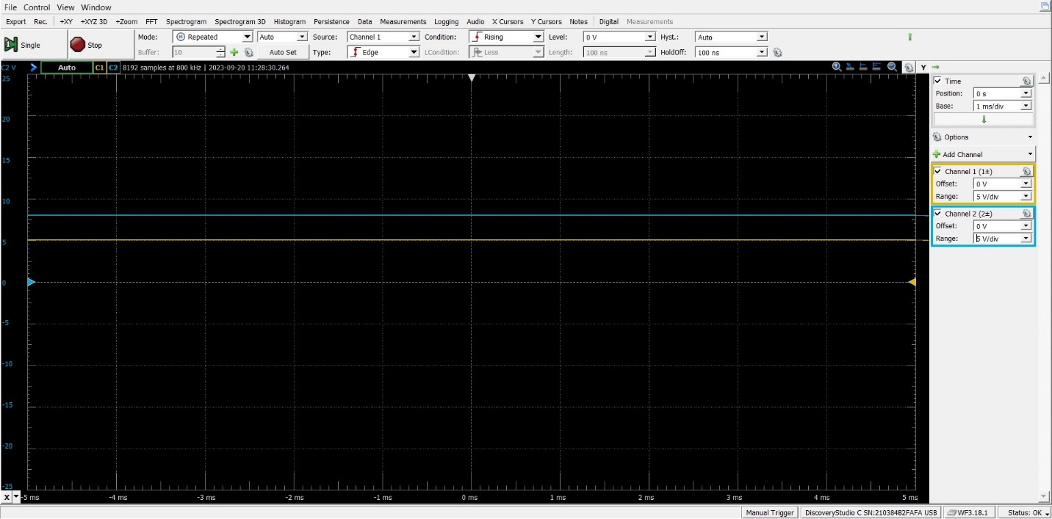

Figure : Input of 8V, resulting in just under 5V

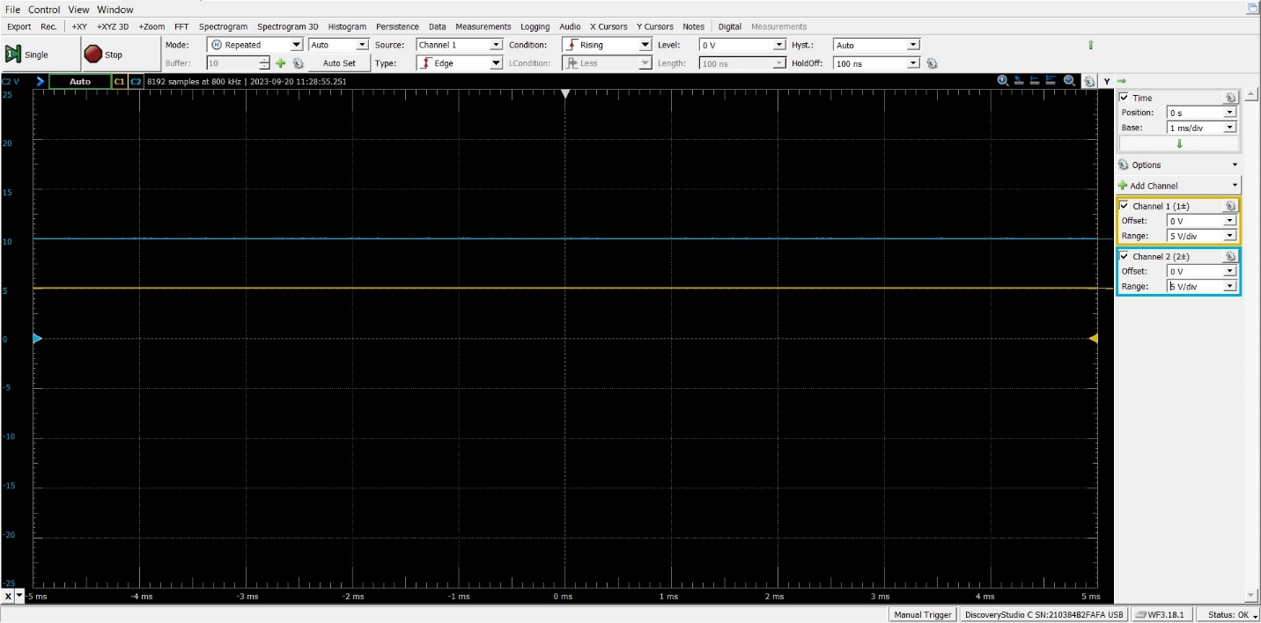

Figure : Input of 10V resulting in 5V

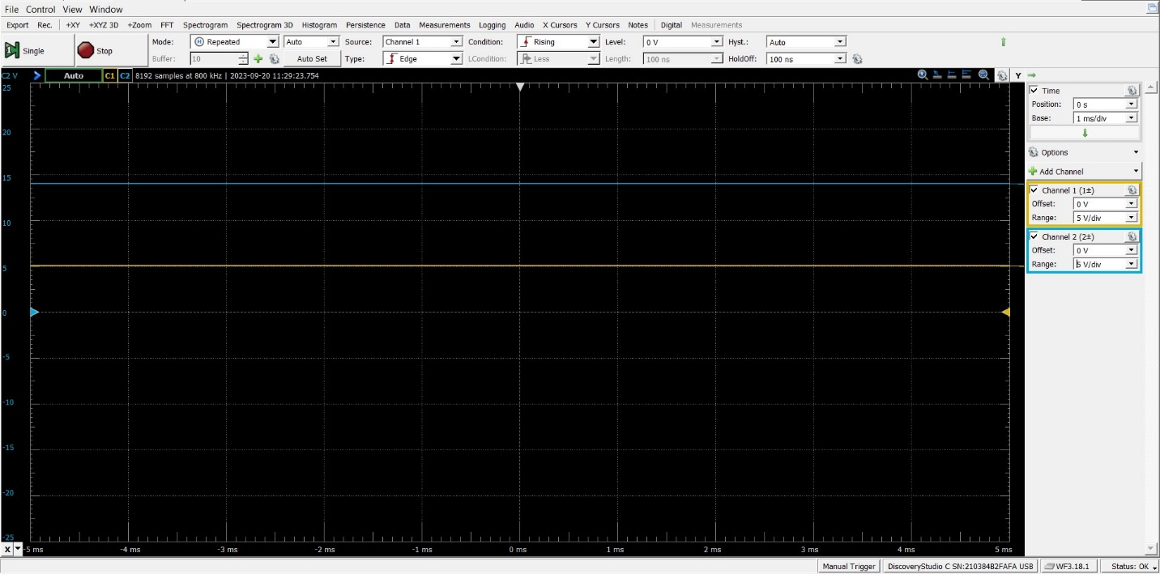

Figure : Input of 14V still results in 5V

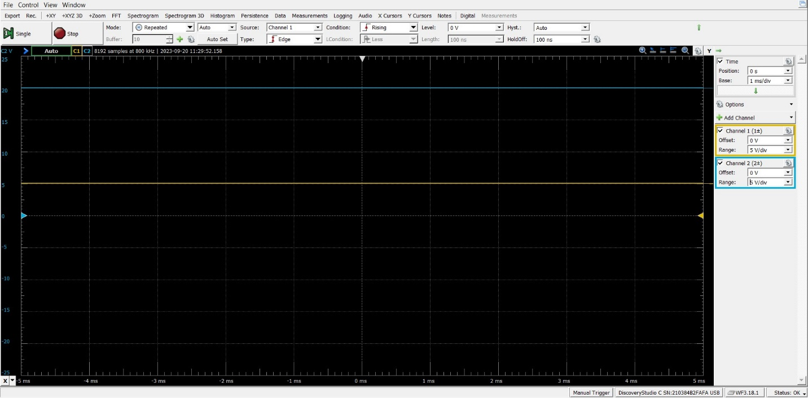

Figure : Power Conditioning Circuit Schematic